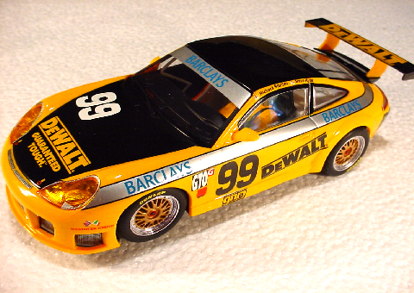
Just going to do a slightly different start to the review this month! Do we take packaging for granted.??
Take a look at this.
This car was ordered from Armchair Racer and the slot car store chick who works there (Laura) is in charge of packaging. The car was ordered and arrived 2 days later and you can always tell when its been wrapped up by Laura, ‘cause ‘ya can’t get the damn tape off the box. It must be a chick thing. Anyhow, the main thing is it’s comes wrapped up tight, no chance of any movement and or most importantly, no damage during transportation and definitely no-one getting a sneak preview before you get it.

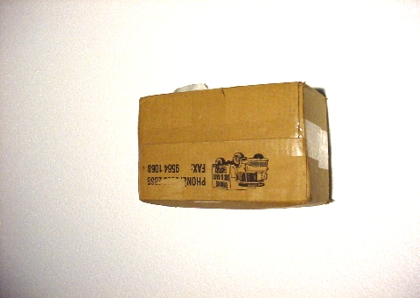

Box arrived. (Here’s a replica box we prepared earlier, with the sticking tape removed of course. We haven’t managed to get the tape off the first box yet.)
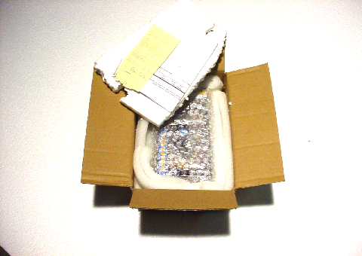
The box comes, Styro-foam packing underneath the folded box top. First thing we notice after removal of the Styro-foam is the receipt. Two things of note here, Laura is so good at taping you can’t work out how and where she started taping to know where to start taking it off, and of course more importantly, placement of the receipt on top of the parcel, ( this is where Jim comes into it) so you can quickly grab the receipt and get it out of your wife’s sight, ..fast!

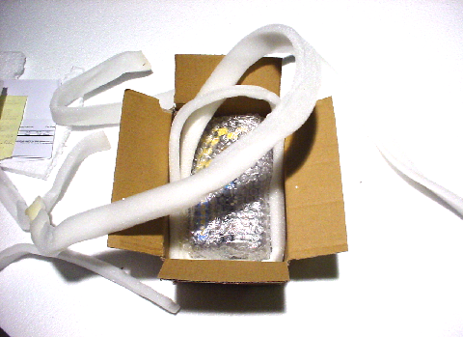

As we can plainly see, soft protective foam gently nuzzles the plastic box and any possible damage from an unforeseen side intrusion. Everything else is wrapped in bubble wrap. This new car is in the now familiar hard plastic case which I feel is an improvement from the old cardboard boxes. Sure they might fracture every now and then but the impact this new plastic case is able to absorb is now greatly increased as opposed to the old cardboard ones. I’m sure these now make it easier to transport the latest cars without too much breakage.
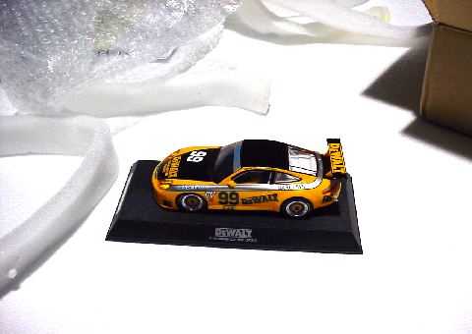
Packaging out, car removed.
Beauty, my new Porsche. Here’s where the fun begins.

On to the review.

Weight 83 grams
Height 38mm
Wheel base at centre of axles 73.5mm
Length of car 137.5mm
Rear wheel track 58mm
Motor config.> Sidewinder

The Porsche Cup series we see running at various countries around the world are now considered premier events as well as some of the most popular viewing for motor sport enthusiasts. Identical in design, the car lends itself to a format not enjoyed by many other makes. The name Porsche is synonymous with motor sport throughout history and as such Hornby add yet another of these prestigious Porsches, to an already impressive stable in the Scalextric range. This latest car is the #99 DeWalt Porsche, and it’s in a familiar Yellow/ Black livery much the same of the American made DeWalt power tool range. This particular Porsche has already built a name for itself in the USA, the Americans obviously identifying with this well known tool brand name. This car looks sensational with its gold wheels Dunlop tyres and excellent engine detail.
The front spoiler on this car must be getting on for one of the lowest to the ground as far as ground clearance goes, so watch out on the old Classic track for any surface imperfections which might catch you out. The new sport tracks should be fine given its development in the area of track support and it will be interesting to see if the new system stays “flat.”
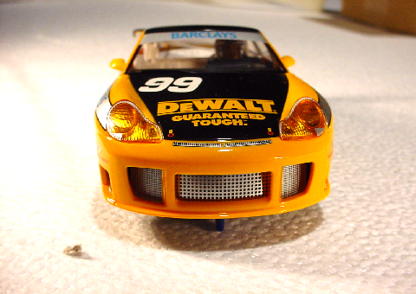

The car ran well on the existing track here. I’ve had a fair bit of practice in my old 911 GT3 so one can feel a little like the Jim Richards of the Scalextric world being able to jump in this car and give it everything and its holds no frightening surprises. Nicely trued wheels, great rubber for grip and a generic well handling chassis all make this a great little fun car.

I’m a big fan of the Scalextric Saloon car with its top heavy type of handling characteristics. Combined with the speed of the new 16 volt power supply of the new Sport track system, this is certainly the new wave of slot car racing. Crisp clean power propels the new range of cars along at an astonishing rate and you’ll need all your plastic barriers up if you have a little off. I have noticed plenty of damage complaints from those on board tracks about the new cars. Unfortunately, heavy impacts from cars outing themselves from the routed slot and into solid craft wood barriers at huge speeds have never been plastic slot car friendly. Most of my cars are still run around the same old Scalextric track and most corners are still covered by the good old crash barriers. Thankfully most of the cars here are still intact and have only minor marks on them. Most of the white barriers are looking a bit second hand but surprisingly the red ones are fine. I’m told the white barrier reacts with the Light which is kind of interesting and maybe something someone who knows more about this phenomenon could write in and tell us about it. The oval here has some thicker walls, but the typical crash added to the angle of impact is slightly different on a banked oval with the fence no more than 3 inches from the track edge. Most of the corners here have been covered with 5mm thick expansion joint foam, a product used to aid the expansion of concrete slabs against other surfaces, and the cars rarely hit anything but broad-side so the impact is well absorbed against this material.

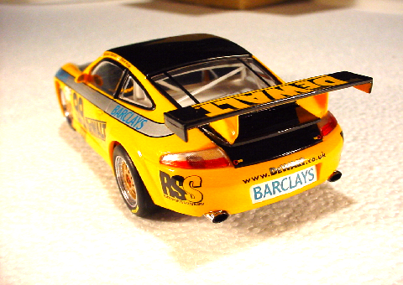

The DeWalt Porsche/ great stuff. Still like my sedans as they skate and tip their way around my track. This one really got the attention of most of my kids and they all wandered down to the shed to have a look at the latest car.
Great to have a car to race against the other Porsche 911/gt3 .
Caution/ Watch the front spoiler. It’s low to the ground and might be subject to a rear ender in the chicanes. Watch the road in front.
Fantastic car. Will be buying more in the future! Should prove to be a great car for club racing.

Makes me wish I bought the DeWalt NASCAR when I had the chance.

Dave Hannaway

